*Guanghui Liu*

*[Company Name] | [Company Address]*

*CONTENT MANAGEMENT SYSTEM*

IIT- Summer CS450 Project

Project Introduction

本项目是一个Content Management System， 用户可以发送特定消息给特定的群组，并可以管理这些信息。 作为信息的接受者，可以浏览这些信息，并下载信息附带的附件。 还可以对文章进行评论，收藏。 本项目类似My IIT中的Black Board 功能。

你可以点击下面的链接访问我们的项目

<http://81.70.89.185:8080/hello>

团队介绍

1. 团队介绍
   1. 团队成员

|  |  |  |
| --- | --- | --- |
| Name | CWID | Mail |
| Guanghui Liu | A20551379 | gliu32@hawk.iit.edu |
| Chenyang Miao | A20526394 | cmiao3@hawk.iit.edu |
| Da Ma | A20551575 | dma13@hawk.iit.edu |

* 1. 团队分工

1. 技术介绍
   1. 编程语言

|  |  |  |  |
| --- | --- | --- | --- |
| Terminal | Development Language | Framework | DB |
| Backend | Java/SQL | Spring Cloud | My SQL |
| Frontend | Html/CSS/Java Script | VUE/NPM/Node JS |  |

* 1. 工具/平台说明
     1. Trello – 工作分工，进度追踪，问题汇总

我们使用Trello来分配任务，并追踪任务进度，我们拆分Feature II 级别的任务分到到每个Card of Board并分配负责人，每当任务完成，更改，或出现需要解决的问题，会自动发送邮件给负责人便于及时的解决问题。

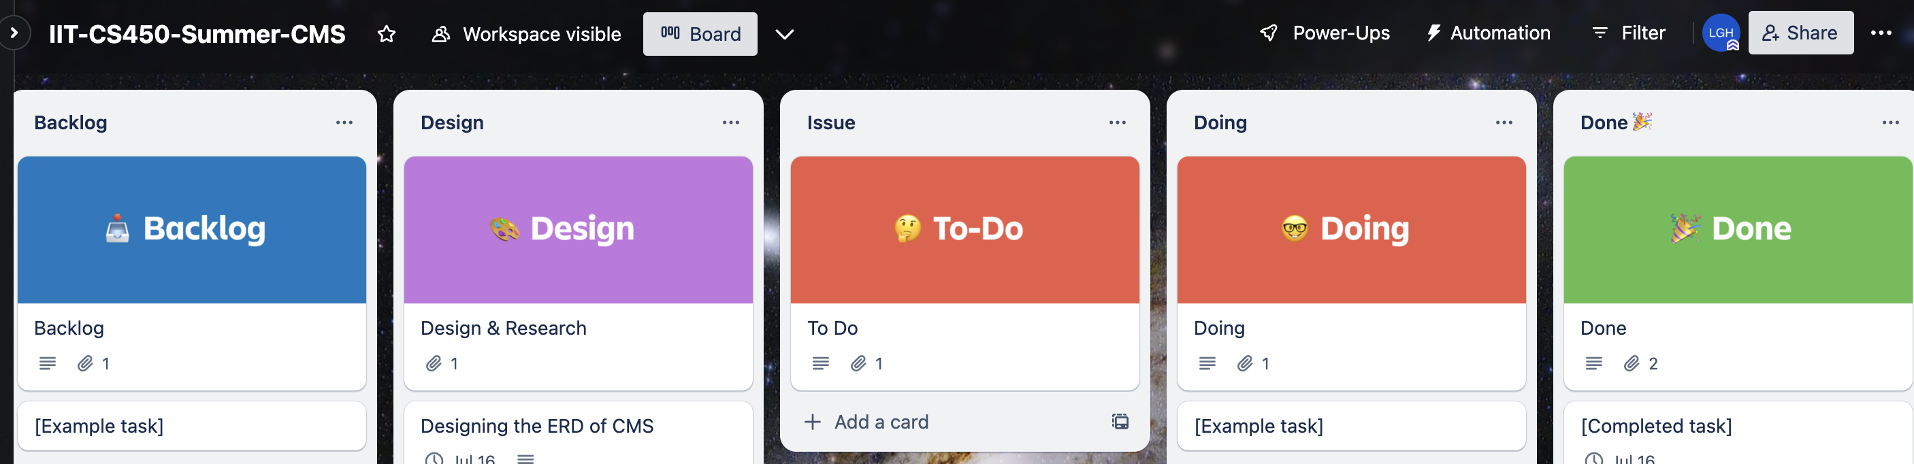

* + 1. DrawIO – ERD 和软件架构图绘制软件

本次项目的第一和第二个的阶段的ERD均使用这个软件完成的设计

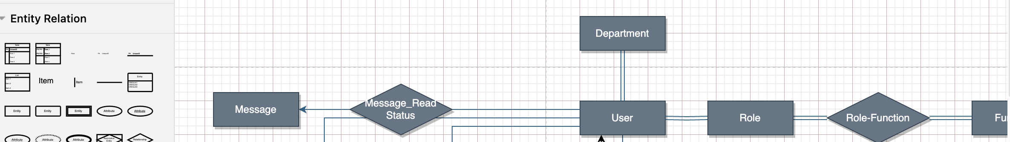

你可以点击以下连接来获取我们的源文件

* + 1. GitHub – 多人协作代码托管平台

描述….

* + 1. ApiFox – Api模拟及Api文档管理平台（多人协作）

描述….

* + 1. Tencent Cloud 云平台，项目运行平台

描述….

* + 1. PostMan

描述…

1. Database & Application Design
   1. Table Summary

|  |  |  |
| --- | --- | --- |
| Table Name | Type | Describe |
| User | - Entity - |  |
| Department | - Entity - |  |
| Role | - Entity - |  |
| Function | - Entity - |  |
| Role_Function | - Relationship - |  |
| Article | - Entity - |  |
| Comments | - Entity - |  |
| Article_Read_Status | - Relationship - |  |
| Favorite | - Relationship - |  |
| Category | - Entity - |  |
| Attachment | - Entity - |  |
| Media | - Entity - |  |
| Browse_History | - Relationship - |  |
| Operate_History | - Relationship - |  |
| Message | - Entity - |  |
| Message_Read_Status | - Relationship - |  |

* 1. ERD

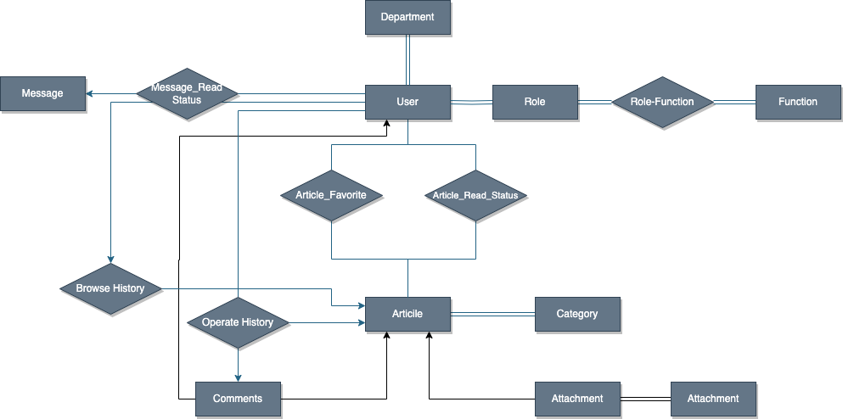

* 1. 关系图
     1. Overview

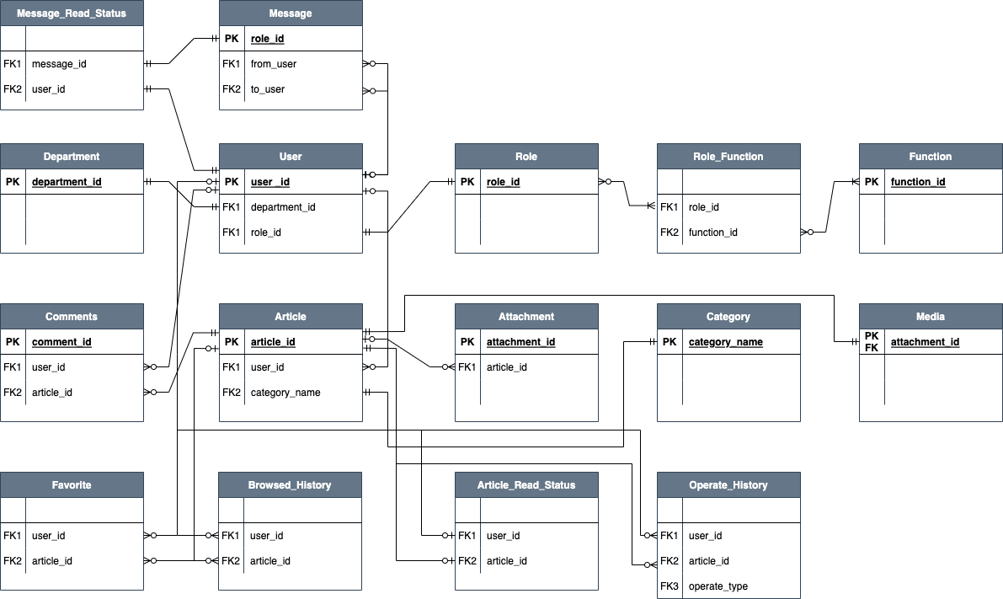

* + 1. 关系图

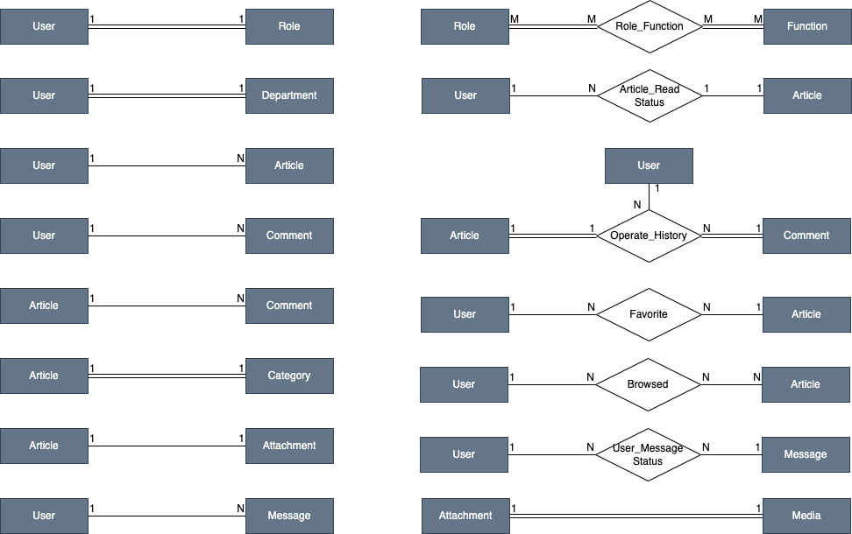

* 1. materialized

以下是各个表的物化信息

* + 1. User Table

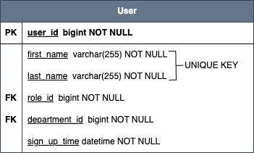

**CREATE** **TABLE** `user` (

`user_id` **bigint** **NOT** **NULL**,

`dept_id` **bigint** **NOT** **NULL**,

`role_id` **bigint** **NOT** **NULL**,

`first_name` **varchar**(255) **NOT** **NULL**,

`last_name` **varchar**(255) **NOT** **NULL**,

`sign_up` **datetime** **NOT** **NULL**,

**PRIMARY** **KEY** (`user_id`),

**UNIQUE** **KEY** `dept_id_UN` (`dept_id`),

**UNIQUE** **KEY** `role_id_UN` (`role_id`),

**UNIQUE** **KEY** `user_name_combin_UN` (`first_name`,`last_name`),

**CONSTRAINT** `user_dept_id_FK` **FOREIGN** **KEY** (`dept_id`) **REFERENCES** `department` (`dept_id`),

**CONSTRAINT** `user_role_id_FK` **FOREIGN** **KEY** (`role_id`) **REFERENCES** `role` (`role_id`))

* + 1. Department Table

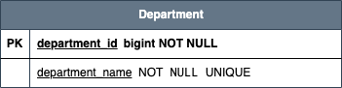

**CREATE** **TABLE** `department` (

`dept_id` **bigint** **NOT** **NULL**,

`dept_name` **varchar**(45) **NOT** **NULL**,

**PRIMARY** **KEY** (`dept_id`),

**UNIQUE** **KEY** `dept_name_UNIQUE` (`dept_name`))

* + 1. Role Table

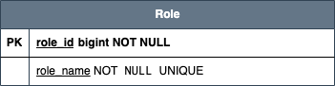

**CREATE** **TABLE** `role` (

`role_id` **bigint** **NOT** **NULL**,

`role_name` **varchar**(45) **NOT** **NULL**,

**PRIMARY** **KEY** (`role_id`),

**UNIQUE** **KEY** `role_name_UNIQUE` (`role_name`),

**CONSTRAINT** `role_name_check`

**CHECK** ((`role_name` **in** ('Viewer','Author','Admin'))))

* + 1. Function Table

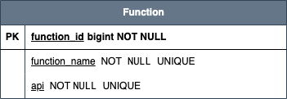

**CREATE** **TABLE** `function` (

`function_id` **bigint** **NOT** **NULL**,

`function_name` **varchar**(45) **NOT** **NULL**,

`url` **text** **NOT** **NULL**,

`api` **varchar**(100) **NOT** **NULL**,

**PRIMARY** **KEY** (`function_id`),

**UNIQUE** **KEY** `function_name_UNIQUE` (`function_name`),

**UNIQUE** **KEY** `function_api_UN` (`api`))

* + 1. Role_Function Table

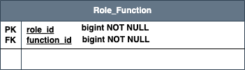

**CREATE** **TABLE** `role_function` (

`role_id` **bigint** **NOT** **NULL**,

`function_id` **bigint** **NOT** **NULL**,

**PRIMARY** **KEY** (`role_id`,`function_id`),

**KEY** `role_function_function_id_FK` (`function_id`),

**CONSTRAINT** `role_function_function_id_FK` **FOREIGN** **KEY** (`function_id`) **REFERENCES** `function` (`function_id`),

**CONSTRAINT** `role_function_role_id_FK` **FOREIGN** **KEY** (`role_id`) **REFERENCES** `role` (`role_id`))

* + 1. Article Table

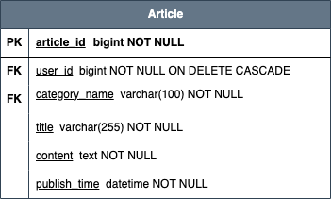

**CREATE** **TABLE** `article` (

`article_id` **bigint** **NOT** **NULL**,

`user_id` **bigint** **NOT** **NULL**,

`category_name` **varchar**(100) **NOT** **NULL**,

`title` **varchar**(255) **NOT** **NULL**,

`content` **text** **NOT** **NULL**,

`publish_time` **datetime** **NOT** **NULL**,

**PRIMARY** **KEY** (`article_id`),

**KEY** `article_user_id_FK` (`user_id`),

**KEY** `article_category_FK` (`category_name`),

**CONSTRAINT** `article_category_FK` **FOREIGN** **KEY** (`category_name`) **REFERENCES** `category` (`category_name`),

**CONSTRAINT** `article_user_id_FK` **FOREIGN** **KEY** (`user_id`) **REFERENCES** `user` (`user_id`) **ON** **DELETE** **CASCADE**)

* + 1. Favorite Table

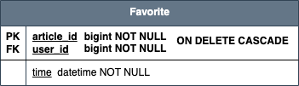

**CREATE** **TABLE** `favorite` (

`user_id` **bigint** **NOT** **NULL**,

`article_id` **bigint** **NOT** **NULL**,

`time` **datetime** **DEFAULT** **NULL**,

**KEY** `favorite_user_FK` (`user_id`),

**KEY** `favorite_article_FK` (`article_id`),

**CONSTRAINT** `favorite_article_FK` **FOREIGN** **KEY** (`article_id`) **REFERENCES** `article` (`article_id`) **ON** **DELETE** **CASCADE**,

**CONSTRAINT** `favorite_user_FK` **FOREIGN** **KEY** (`user_id`) **REFERENCES** `user` (`user_id`) **ON** **DELETE** **CASCADE**)

* + 1. Category Table

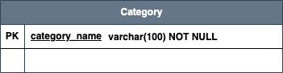

**CREATE** **TABLE** `category` (

`category_name` **varchar**(100) **NOT** **NULL**,

**PRIMARY** **KEY** (`category_name`))

* + 1. Attachment Table

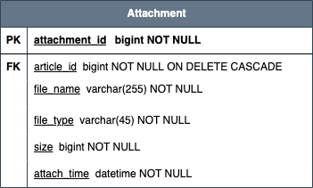

**CREATE** **TABLE** `attachment` (

`attachment_id` **bigint** **NOT** **NULL**,

`article_id` **bigint** **NOT** **NULL**,

`file_name` **varchar**(255) **NOT** **NULL**,

`file_type` **varchar**(45) **NOT** **NULL**,

`size` **bigint** **NOT** **NULL**,

`attach_time` **datetime** **NOT** **NULL**,

**PRIMARY** **KEY** (`attachment_id`),

**KEY** `attachment_FK` (`article_id`),

**CONSTRAINT** `attachment_FK` **FOREIGN** **KEY** (`article_id`) **REFERENCES** `article` (`article_id`) **ON** **DELETE** **CASCADE**)

* + 1. Media Table

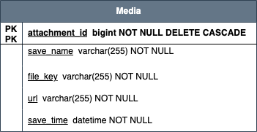

**CREATE** **TABLE** `media` (

`attachment_id` **bigint** **NOT** **NULL**,

`save_name` **varchar**(255) **NOT** **NULL**,

`file_key` **varchar**(255) **NOT** **NULL**,

`url` **varchar**(255) **NOT** **NULL**,

`save_time` **datetime** **NOT** **NULL**,

**PRIMARY** **KEY** (`attachment_id`),

**CONSTRAINT** `media_FK` **FOREIGN** **KEY** (`attachment_id`) **REFERENCES** `attachment` (`attachment_id`) **ON** **DELETE** **CASCADE** **ON** **UPDATE** **CASCADE**)

* + 1. Comments Table

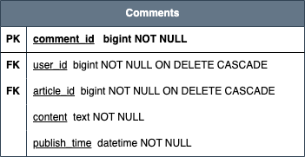

**CREATE** **TABLE** `comments` (

`comment_id` **bigint** **NOT** **NULL**,

`user_id` **bigint** **NOT** **NULL**,

`article_id` **bigint** **NOT** **NULL**,

`content` **text** **NOT** **NULL**,

`publish_time` **datetime** **NOT** **NULL**,

**PRIMARY** **KEY** (`comment_id`),

**KEY** `comments_article_FK` (`article_id`),

**KEY** `comments_FK` (`user_id`),

**CONSTRAINT** `comments_article_FK` **FOREIGN** **KEY** (`article_id`) **REFERENCES** `article` (`article_id`) **ON** **DELETE** **CASCADE**,

**CONSTRAINT** `comments_FK` **FOREIGN** **KEY** (`user_id`) **REFERENCES** `user` (`user_id`) **ON** **DELETE** **CASCADE**)

* + 1. Article_read_status tables

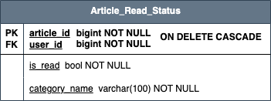

**CREATE** **TABLE** `article_read_status` (

`article_id` **bigint** **NOT** **NULL**,

`user_id` **bigint** **NOT** **NULL**,

`is_read` **tinyint**(1) **NOT** **NULL**,

`read_time` **datetime** **NOT** **NULL**,

**PRIMARY** **KEY** (`article_id`,`user_id`),

**KEY** `article_read_status_user_FK` (`user_id`),

**CONSTRAINT** `article_read_status_FK` **FOREIGN** **KEY** (`article_id`) **REFERENCES** `article` (`article_id`) **ON** **DELETE** **CASCADE**,

**CONSTRAINT** `article_read_status_user_FK` **FOREIGN** **KEY** (`user_id`) **REFERENCES** `user` (`user_id`) **ON** **DELETE** **CASCADE**)

* + 1. browsed_read_status

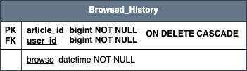

**CREATE** **TABLE** `browsed_history` (

`article_id` **bigint** **NOT** **NULL**,

`user_id` **bigint** **NOT** **NULL**,

`browse_time` **datetime** **NOT** **NULL**,

**PRIMARY** **KEY** (`article_id`,`user_id`),

**KEY** `browsed_history_user_FK` (`user_id`),

**CONSTRAINT** `browsed_history_article_FK` **FOREIGN** **KEY** (`article_id`) **REFERENCES** `article` (`article_id`) **ON** **DELETE** **CASCADE**,

**CONSTRAINT** `browsed_history_user_FK` **FOREIGN** **KEY** (`user_id`) **REFERENCES** `user` (`user_id`) **ON** **DELETE** **CASCADE**)

* + 1. operate_history

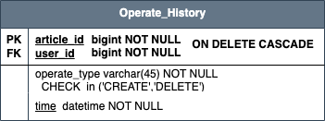

**CREATE** **TABLE** `operate_history` (

`user_id` **bigint** **NOT** **NULL**,

`article_id` **bigint** **NOT** **NULL**,

`operate_type` **varchar**(100) **NOT** **NULL**,

`time` **datetime** **NOT** **NULL**,

**KEY** `operate_history_user_FK` (`user_id`),

**KEY** `operate_history_comment_FK` (`article_id`),

**CONSTRAINT** `operate_history_comment_FK` **FOREIGN** **KEY** (`article_id`) **REFERENCES** `article` (`article_id`),

**CONSTRAINT** `operate_history_user_FK` **FOREIGN** **KEY** (`user_id`) **REFERENCES** `user` (`user_id`),

**CONSTRAINT** `operate_history_CHECK` **CHECK** ((`operate_type` **in** ('CREATE','DELETE'))))

* + 1. Message

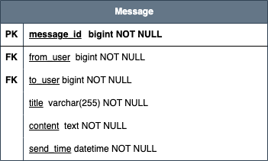

**CREATE** **TABLE** `message` (

`message_id` **bigint** **NOT** **NULL**,

`from_user` **bigint** **NOT** **NULL**,

`to_user` **bigint** **NOT** **NULL**,

`title` **varchar**(255) **NOT** **NULL**,

`content` **text** **NOT** **NULL**,

`send_time` **datetime** **NOT** **NULL**,

**PRIMARY** **KEY** (`message_id`),

**KEY** `message_from_FK` (`from_user`),

**KEY** `message_to_FK` (`to_user`),

**CONSTRAINT** `message_from_FK` **FOREIGN** **KEY** (`from_user`) **REFERENCES** `user` (`user_id`),

**CONSTRAINT** `message_to_FK` **FOREIGN** **KEY** (`to_user`) **REFERENCES** `user` (`user_id`))

* + 1. Message_Read_status

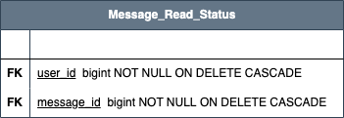

**CREATE** **TABLE** `message_read_status` (

`message_id` **bigint** **NOT** **NULL**,

`user_id` **bigint** **NOT** **NULL**,

`is_read` **tinyint**(1) **NOT** **NULL** **DEFAULT** '0',

**KEY** `message_read_status_user_FK` (`user_id`),

**KEY** `message_read_status_msg_FK` (`message_id`),

**CONSTRAINT** `message_read_status_msg_FK` **FOREIGN** **KEY** (`message_id`) **REFERENCES** `message` (`message_id`) **ON** **DELETE** **CASCADE**,

**CONSTRAINT** `message_read_status_user_FK` **FOREIGN** **KEY** (`user_id`) **REFERENCES** `user` (`user_id`) **ON** **DELETE** **CASCADE**)

* + 1. a
    2. a
    3. a
    4. a
    5. a
    6. a
    7. a
    8. a
    9. a
    10. a
  1. ER in DB
  2. 软件架构图

1. 项目关键功能说明
   1. 发送文章
   2. 查看文章
   3. 用户系统